THE PRESIDENT’S OFFICE
REGIONAL ADMINISTRATION AND LOCAL GOVERNMENT
FORM TWO JOINT EXAMINATION FOR GOVERNMENT SCHOOLS –JEGOS


PRE-MOCK EXAMINATION
033 BIOLOGY

MARKING SCHEME 2024

SECTION A (15 MARKS)

i | ii | iii | iv | v | vi | vii | viii | ix | x
B | C | B | D | A | B | C | A | C | D

i | ii | iii | iv | v
F | D | I | B | E

SECTION B (70 Marks)
Answer ALL questions from this section

- (a)
- Humans and dogs (Cows, lions…)
- Scorpion and spider
- Fish and shrimps (Tadpoles, mayflies, damselflies…)
- Grasshopper and cockroach (mosquito, houseflies…)
- Grass and beans (Orange tree, coconut tree…)
(00½ @ =5 marks)
(b) Aerobic respiration is the respiration that requires oxygen. The end products of aerobic respiration are carbon dioxide, water and energy. (02½ marks)
Anaerobic respiration is the respiration that takes place in the absence of oxygen. The end products of anaerobic respiration are carbon dioxide, alcohol or lactic acid and energy. (02½ marks)

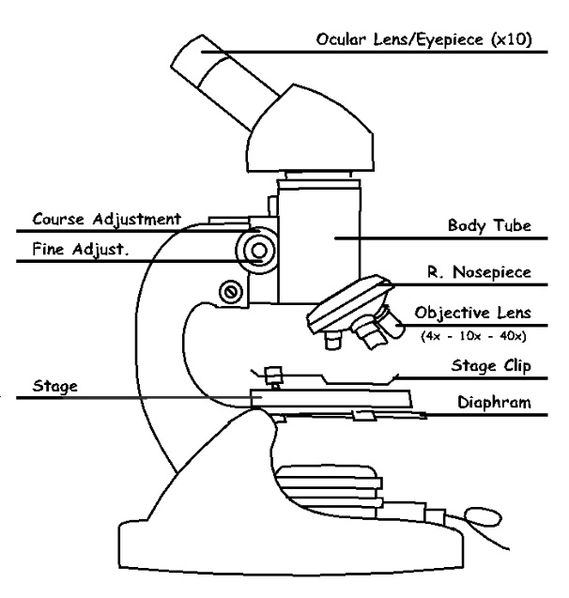
- (a) Diagram of a light microscope

(Diagram: 01½ marks
Labels 0½@ = 04½ marks)

(b) Functions of parts of the light microscope:
- Eyepiece lens (Ocular lens): it is located at the top of the body tube and it is used to magnify specimen after having been magnified by the objective lens. The magnifying power of the eye piece lens is usually X15 or X10 (which means it magnifies specimen after having been magnified by the objective lens fifteen or ten times more).
- Body tube: A hollow tube that support the eyepiece and the revolving nose piece.
- Revolving nose piece: it supports the objective lenses.
- Objective lens: - It is used for directly magnifying specimen. Objective lenses come in various magnifying powers.
(Any four 01@ = 04 marks)

- (a)
- Infection is a disease caused by an organism while Pathogen is an organism which can cause a disease e.g. Virus.
(02 marks)

- Vector is an organism that transmits diseases causing microorganisms whole Host is an organism in which a pathogen lives example, Human beings.
(02 marks)

(b) Communicable diseases are diseases that can be transmitted from one person to another; they are diseases that are caused by pathogen.
(01½ marks)

Communicable diseases can be categorized as epidemic, pandemic and endemic.
- Epidemic:
Is a disease which spreads quickly and affect a large number of people in an area over a short period of time; example; measles, cholera, and meningitis.
(01½ marks)

- Pandemic:
Is a disease that affects the large area like several countries at a time, even a whole continent; example, HIV/AIDS.
(01½ marks)

- Endemic:
Is a disease that is always found in a certain region continuously; example, Bilharzia and malaria.
(01½ marks)

(Total: 10 marks)

6. (a) The cell theory states that:
- All living things are composed of cells
- The cell is the basic unit in living things
- All cells are produced from other cells
- Cells contain inherited information which controls their activities
- All life processes take place in the cell
(01½ @ = 06 marks)

(b)
- Cell membrane: the cell membrane (also called plasma membrane or plasma lemma) is a thin semi permeable layer which encloses the animal cell. Its functions are: to protect the cell and to control the movement of material in and out of the cell. The cell membrane together with the cytoplasm is called protoplasm.
- Cytoplasm: this is the semi-fluid material made up of water and dissolved chemical substances. Its functions are: - it provides the site for chemical reactions, - it supports cell organelles
- Nucleus: this is an oval or spherical organelle suspended in the cytoplasm. The nucleus is made up of the fluid called nucleoplasm and has structures called chromosomes. The membrane around the nucleus is called nuclear membrane. Its functions are: -to control the functions of all other parts of the cell, - to determine the hereditary characteristics
- Mitochondria: these are oval-shaped organelles with double membranes. Its function is: to produce energy (it is the power house of the cell).
(01 @ = 04 marks)

(Total: 10 marks)

7. (a) There is a difference: food processing involves activities that change raw food to a state that can be used for a specific purpose, example, processing tomato fruits into ketchup (tomato sauce). Food preservation involve processing that prolong the shelf life of the food. (in other words, food preservation encompasses food processing but food processing may not necessarily mean preservation (the food may be processed for immediate use).
(04 marks)

(b)
- Developing and use Sun drying techniques. It involves the exposing of the food to the sunlight for drying. Stakeholders can construct solar dryers for making sundried tomatoes.
- Use of canning technique; Canning involves cooking food, sealing it in sterile cans or jars, and boiling the containers to kill or weaken any remaining bacteria as a form of sterilization.
- Use of Modified atmosphere/controlled atmosphere: Modifying atmosphere is a way to preserve food by operating on the atmosphere around it. Tomatoes that are notoriously difficult to preserve can be packaged in sealed bags with an atmosphere modified to reduce the oxygen (O₂) concentration and increase the carbon dioxide (CO₂) concentration. Carbon dioxide prevents insects and, depending on concentration, prevents mold and oxidation.
(02@ = 06 marks)

(Total: 10 marks)
8. (a)
- Species
- Artificial classification
- Kingdom
01@ = 04 marks
- Classification
(b)
Four advantages of fungi.
(i) Direct source of food, example edible mushrooms
(ii) Used in the food industry to manufacture foods, example, yeast
(iii) Source of medicine, for example, penicillin
(iv) Decomposers/recycling of materials, example, saprophytic fungi
01@ = 04 marks
(c) Two disadvantages of fungi.
(i) Cause diseases to plants and animals, example parasitic fungi (examples of human fungal diseases are ringworm and candidiasis, plant fungal diseases are powdery mildews and smuts)
(ii) they spoil foods, for example bread mould (mucor)
01@ = 02 marks

(Total: 10 marks)

9. (a) (i) It saves life as it may prevent an immediate cause of death such as loss of too much blood
01½ marks
01½ marks

(ii) Could avert permanent damage ….
01½ marks
(iii) It may reduce treatment cost by minimizing the consequences of the injury
(iv) It reduces pain and suffering …..
01½ marks
(b)
- Severe bleeding with blood flowing out rapidly must be stopped at once by pressing with fingers directly on the wound or pressing the edges of the wound together.
01 marks
01 marks
- Lay the victim down.
- If the wound is in a limb raise it provided it is not fractured.
01 marks
- When the bleeding has slowed down press a pad of material over the wound and tie it rapidly in place.
01 marks

(Total: 10 marks)

SECTION C (15 Marks)

10.
HIV-AIDS
Intro: HIV is Human Immune deficiency virus and AIDS is Acquired Immune deficiency syndrome. (00½ mark)
- Cause: AIDS is caused by Human Immune deficiency virus (HIV). HIV is mainly found in body fluids such as semen, blood and vaginal secretions.
01 mark
- Mode of transmission: (1) Unprotected sexual intercourse. (2) Sharing sharp objects. (3) Unscreened blood transfusion. (4) From mother to child at birth or breast feeding (5) Accidents where bleeding occurs to the victims and blood mix. (any four points,
01 @ = 04 marks)

- Symptoms and effect: (1) cancer of the skin and blood vessels called Kaposis sarcoma (2) Abnormal inflammation of lymph nodes. (3) Fever and diarrhoea for more than one month. (4) Severe cough for more than one month. (5) Loss of weight. (6) Skin infections. (7) Pneumonia caused by Pneumocytis carinii protozoa.
01 @ = 04 marks)
(any four points,

- Control (prevention and treatment): (1) not having sexual intercourse (abstinence). (2) By using condom (3) By not sharing sex partners. (4) Not sharing sharp objects. (5) Screening blood for blood transfusion. (6) Taking regular HIV tests (this can help by enabling the taking of HIV treatment drug at the early stages of infection and therefore preventing or reducing its adverse effect) (7) Taking ARVs (HIV treatment drug).
01 @ = 05 marks)
(Any five points,
  - (Conclusion: 00½ mark) (Total: 15 marks)

